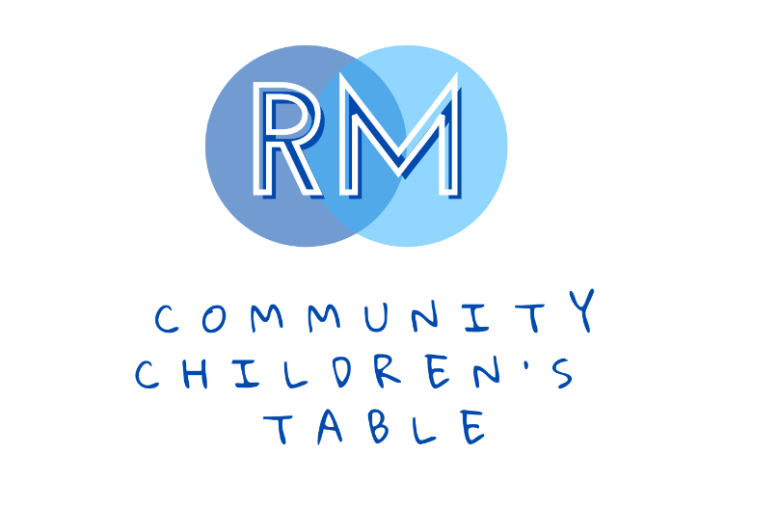
www.rmcchildrenstable.ca

Ridge Meadows Community Children’s Table (RMCCT) Terms of Reference

April 2023

*Living Document – Subject to Change

Mission:
The RMCCT, in partnership with children (prenatal to 12), family and community, promotes opportunities and undertakes initiatives that support the health and well-being of children (prenatal to 12) of Maple Ridge, Pitt Meadows and Katzie.

Vision:
The RMCCT celebrates the amazing children (prenatal to 12) and families of Maple Ridge, Pitt Meadows and Katzie communities. We envision a community that:

- Promotes and respects diversity and the equal rights of all children to develop to their full potential;
- Supports and invests in the future of all children and their families in an engaged and connected community;
- Provides opportunities for the positive development and well-being of all children in our communities.

Guiding Principles:
- Values the "whole" child as a developing individual;
- Recognizes and honours the diversity of children and the communities in which they live and grow;
- Honours and supports the role of relationships in the growth and development of children and families in the communities;
- Is committed to working together with honesty, integrity, inclusivity and respect for all within a process that is transparent, accountable and family centered;
- Is committed to innovation which gives the freedom to take risks and be creative;
- Will cultivate a holistic approach to the work we do with the children and families in the communities;
- Collaborates with children and families to drive the work of the committee;
- Builds capacity by supporting and strengthening relationships amongst the community members, services, programs and resources.

Committee Structure:
The RMCCT is a member table /committee of the Maple Ridge Pitt Meadows Katzie Community Network (CN) Committee. The CN is an inclusive community organization of stakeholders that views the community from a holistic perspective. The network provides an opportunity for community-wide planning, development of community solutions and collaboration. The network supports and encourages opportunities for children, youth and families to increase their capacity to improve their quality of life.

The RMCCT will utilize the CN newsletter for dissemination of committee and representing agency information.

RMCCT Regular Committee
The Regular Committee meetings are used for:
- networking | - resource sharing
- strategic planning | - allocation of revenue
- input on service development and evaluation | - annual work planning
- mutual support and celebration of community.

The RMCCT will follow the work plan adopted in December of 2019.

RMCCT Working Groups
Within the committee’s strategic plan, the RMCCT has determined that at times there may be a need for Task Groups. RMCCT Task Groups are occasionally created to address our Work Plan deliverables and could include:
- Grant Writing
- Special Planning
- Events
- Marketing and Promotion

Committee Organization:

Membership
RMCCT is currently comprised of a collaborative group of professionals, service providers and community members who represent different areas of child development in Ridge Meadows and have ongoing contact with families with young children. Membership is voluntary and active members include:

- The Family Education &  - Support Centre | - Ridge Meadows Association  for Community Living | - Maple Ridge Pitt Meadows  - Community Services
- Ridge Meadows Child  - Development Centre | - Fraser River Indigenous  Society | - Maple Ridge & Pitt Meadows  - Public Libraries
- MCFD | - School District 42 | - Fraser Health Authority – Public Health
- Westcoast Family Centres | - Maple Ridge ACT | - The City of Maple Ridge
- Independent Service Providers

There is no membership fee and membership is open to all community members that have an interest in supporting the health and well-being of children under 12 and their families.

Committee Meetings Dates, Times & Locations
The RMCCT Committee meets monthly, the third Wednesday of every month from 1 to 3pm. We do not typically meet in July, August and December. Meetings could be held in person or virtual. For the in person meetings, location will be agreed on among members.

Agenda development and Minutes
Meeting agendas are developed by the chairs or the Coordinator (provided there is funding for the Coordinator) using an agenda template.

The minutes will include all relevant discussion, recommendations and updates by committee members. Committee members are to submit updates to the chairs/ minute taker, to add to the Community Updates section of the Regular RMCCT minutes, at the meeting or after the meeting, for minutes to be distributed in a timely fashion. The minute taker role is to be of a term of two years.

Decision making
The RMCCT and its Task Groups make decisions by consensus of the members present at the meeting. It is agreed that consensus pertains to a ‘round table discussion and comment’ by each participating member to express their input towards the decision. All recommendations are sought by the Committee Chairs and captured in the meeting minutes. Working groups recommendations are to be forwarded to the RMCCT where a final decision is made unless they have given autonomy for Working Groups to make decisions.

It is recognized that items for further discussion and decision making may be carried forward to a following meeting prior to a decision-taking place. Members are encouraged to ask the Chairs for extension of time for adequate time to process issues prior to decision.

In some cases, where time sensitive decisions are required, it is acknowledged input and consensus may be necessary through the use of email conversations. When such requirements are needed, time deadlines will be clearly noted in the emails as well as indicating non-response to such requests may be interpreted as approval.

Communication
RMCCT fosters a transparent, respectful and collaborative atmosphere of communication. All relevant communication is sent in a timely fashion, including agendas and minutes.
The flow of information is an important element to successful committee communication:
- For Projects and/or programs that resulted from and submitted by RMCCT, reporting back to all committee members will be determined as of the point of application
- Any queries to the table of a political or controversial nature will be addressed by the Chairs and Committee.
- While participation at RMCCT is open and inclusive, anyone who ‘represents’ the committee must be delegated by the group to do so.

Conflict Resolution Procedure

- Should an RMCCT member encounter a conflict with a Committee member or from someone outside the Committee, it is expected that this matter would be directed to the Chairs of the RMCCT.
- A scheduled meeting/phone meeting will take place with the Committee Chairs. Specific concerns will be shared in a respectful and straight forward manner.
- Both parties will have the opportunity to address concerns with the goal of clarifying the core issue/issues.
- When there is agreement as to the core issue/s, possible solutions will be discussed, and the development of a resolution will be worked on by both parties.
- Agreement on a solution will be generated and put in writing with a clear action plan.
- The agreement will be put in place and reviewed on an agreed upon time line. (Or as needed).
- If no agreement is possible, the dispute will be taken to the CN Facilitator’s group. If a CN
Facilitator is involved in the dispute, they would excuse themselves from the process.
- A recommendation will be made by the Facilitator’s group and communicated to the Chairs of the RMCCT. The Chairs of the Committee will confer parties involved with the recommendation as a final decision.

Committee Chairs
The RMCCT is supported by Joint Chairs representing two separate agencies (and Coordinator, depending on funding). The Joint Chairs position is accepted on a voluntary basis through an annual election process that takes place in June for a term of two years and a chair can return after those two years if the table agrees. The duties of the Committee Chairs include: developing, in conjunction with the Coordinator (if funding available), the agenda for the Committee; and to ensure the RMCCT develops and adheres to a current work plan.

