Ridge Meadows Community Children’s Table Meeting Notes

May 13, 2020

1:00 p.m.
Type of Meeting: Via Zoom
Meeting Facilitator: Susan Foster
Attendees: 17
- Territory Acknowledgement
- Share Agenda
- Ask for Additions
- Corrections to Notes from May 6

- Check-in (round)
- Christina/CN Coordinator; putting out ‘what’s happening’ please send your info to me.
- Drea/ SD 42: waiting for direction for June 1, what it will look like. Programming going well, putting out afterschool flyer for activities.
- Afton/PM library: working on programming, ideas for more virtual programming. Watching/waiting for direction from government and library system on how to move forward.
- Ginna/FRIS: we are looking for an EY manager – AIDP, ASCD, projects, CYSN guide. Looking for support to get the word out there, I’ll send the job description to Susan so she can send it out.
- Helen/Westcoast Family: continuing with virtual programming. Looking at how it will look coming back in. We are the food hub, looking at supporting more families. Keeping communication open with moms for needs, support, etc.
- Jackie/City of PM: Postcard has gone out with resources, links, etc. Questions around language – don’t currently have a resource but looking into it. Pitt Meadows day will be virtual June 6th, can check website. Collaborating with webinars through BCRPA about re-entry.
- Jo-Anne/Community Services CCRR; serving food, continuing virtual programming, workshops for service providers. Figuring out how to get some staff in the office.
- John H/RMACL; waiting for provincial directions from worksafe and provincial health around daycares, opening schools, etc. and how it will impact us – and how many will be returning. Received a grant from Vancouver Foundation; very general and broad – allows us to do a lot of things.
- Linda/Fraser Health; things haven’t changed too much. Pushing immunizations, reminding parents, talking to hesitant clients, families, etc.
- Melanie/SD 42: not much change, still waiting to receive more direction – hoping to know by next week. Have some things to put in the newsletter, had some glitches with it last week.
- Natalie/Family Ed: discussing re-opening, what it will look like, etc. Navigator program; distributed Mother’s Day self-care kits, a few families aren’t connected with drop in programs so put together bags for them. Continuing connecting families with food bank, providing gift cards. Family leaf still virtual programming
- Nikki/Family ed: figuring out how the programs will look moving forward. Continuing workshops. Afterschool programming; looking at what September might look like to plan ahead. CCCG; having first Zoom in class for grade 2-3.
- Virginia/Pivot Point; Running parent caregivers’ series. Can look at our calendar link. Services are open for anyone needing/wanting to connect online and some in-person. Welcoming students back into community classroom centers, will take a lot of planning, working on that now. Talking to a lot of frightened families as well. We reached out to mental health program manager (Ginna)
- Wendy/RMACL: looking at bringing staff back and how it will look, how services can start up again. Looking for ideas, enjoy talking to others for this reason as well.
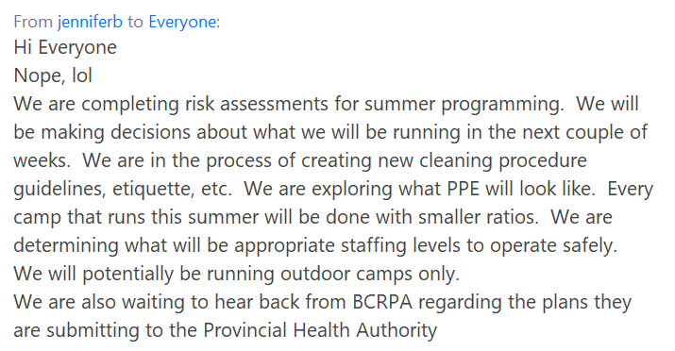
- Business Arising
  - Surveys - Susan/MCFD EY; surveys ready to go just having some translated. Will send out when ready...shooting for week of May 19
  - Website/Facebook Page - Added a button on website; covid resource list but having an issue with domain being active – website not active at the moment – working on that. Will send information out this week again. Natalie; talking with person about Facebook page, they’re contacting me today about it
  - Virtual Platforms Sessions - Virtual platform sessions; polls indicated the best days of the week and the topics; therapy sessions online, family drop in online, special events/celebrations online, parent education online – contact me if interested in helping facilitate these.

- New Business
  - RestartBC – poll and discussion
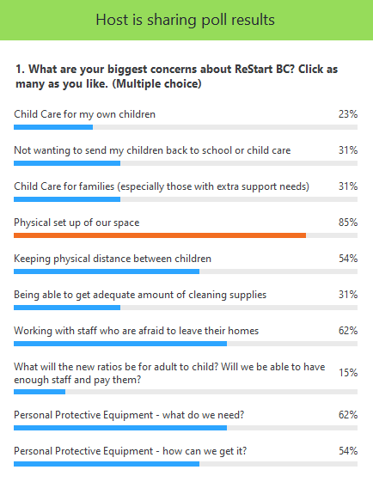
What are people doing about space?
- Virginia; finding it’s important for families to know that we are keeping thing sanitized – so we are publishing the protocols we use. Small tables, larger tables, keeping physical distancing – creating barriers so kids don’t have a choice in how close they get to people.
- Ginna; acknowledging who’s in the office, staff check in with admin – she calendars who is in office. Marking office with tape; X’s, squares to put things down, etc. for those who share cubicles, need to schedule 1 at a time until we get barriers/plexiglass. Sharing space/washrooms with other agencies – what we have control over and what we don’t. If you need links to cleaners or contractors, let me know.
Staff that don’t feel comfortable coming back?
- MCFD; looking at a hybrid model
- Ginna; trust in building people’s production at home, working from work computers not personal, printing, safety, security, connection, etc.
- PPE: hoping to get more information Friday
- Physical distancing with children; not sure how that will be done?
- Christina; we’ve all just gone through this pressure system on changing everything we’ve done to virtual, ground is changing again – slowly this time- a lot of people working hard to be creative, we need to be aware of the pressure that’s coming to change everything again. Need to watch staff for burn out, etc. Be kind to yourself. It’s unrealistic pressure and is changing.
- Linda; remind people that FraserHealth.ca website has a lot under the covid information; anxiety, depression, etc. might be helpful

- Next Meeting – May 20 @ 1:00 p.m.

