Ridge Meadows Community Children’s Table

Meeting Notes

May 27, 2020

1:00 p.m.
Type of Meeting: Via Zoom
Attendees; 17
Meeting Facilitator: Susan Foster
- Territory Acknowledgement
- Ask for Additions; None
- Corrections to Notes from May 20; None
- Check-in (round)
  - Natalie/family Ed: My program has been busy with lots of training this week and last week. I now have access to the FB page. I posted about the survey on there. I created a new email for the Facebook page ridgemeadowsecd@gmail.com
  - Helen/healthy babies (westcoast family centres); meeting about the next phase of coming back to office, etc. what will groups look like? Looking at meeting outside, parks, need approval. Continuing with zoom, developing power points and quizzes, more interactive for moms. We have regulars coming on as well as newcomers that come when they can.
  - Jo-Anne/CCRR; busy with safety things coming into the office. Delivering paper flowers and cookies to approx. 200 care providers, house to house. Zoom workshops continuing, working on busy bags for June
  - Anita/ MRPM (CCRR) pedagogist; working with early learning framework, excited to get back into the field, returning and wanting to check in with everyone to see what’s been happening (first meeting) email me with any questions; agalvin2@uwo.ca
  - Cherie/ Big Brothers Big sisters of FV: moving in school matches to virtual platform, linking with school district. We’re still doing match events virtually, they’ve gone very well. Shuffling happening in office. Working toward more virtual opportunities to keep connections with kids.
  - Jennifer/City of MR; The summer guide will be available on the City of MR website June12th. The summer guide will be digital only (no printed). Registration starts online June 16, 8am and over the phone June 18, 8am. There will be no in-person registration. All available programs have undergone a risk assessment and applicable safety procedures have been put in place for safety. The Skatepark is now open and there are staff there throughout the week to help manage physical distancing practices as well as the amount of people utilizing it at one time. Playgrounds are still closed, we are working through creating new procedures for staff and camp participants for the summer. Park ambassador program will continue to run through June. We are working through all of our preparations for summer camps right now as well as what staff training will look like.
  - Christina/CN Network; working on article “capture voices of youth”, working on a panel of ‘experts’/guest speakers for next CN meeting on June 9th.
  - Drea/SD 42; getting ready for kids coming back. Flyer went home about virtual programs, on district website there will be a new tab ‘activities for parents’ with different links such as museum tours, art online, etc. Karate program offered to teachers as well. Haven’t heard any direction about summer learning yet. Hoping for the go ahead very soon so we can start planning.
  - Liza Morris/library: getting ready as everyone else is. As soon as I hear anything I’ll share.
  - Kerry/FSIBC; FSI is in the process of organizing training on trauma informed practice. We’ve added more security to our zoom calls, all calls are listed on website; themes, etc.
  - Ginna/ FRIS; trying to find larger places for meeting people, office is getting ready to fully open, waiting for policy on groups, etc. launching our new website with a new look, happening on Monday. Will show new programs, connections, self-referrals, etc. www.frisociety.ca
    - Question; doing a national indigenous day event virtually?
      - Yes, we have a list of regular invited guests, will be going through that list and contact each one by email. Just working through this now. Information will be in the email
  - Jenny/Family Ed; doing a virtual multiculturism day. Preparing to get back into office. Have group starting up again and workshops still going. Learning the process of getting people into the building, seating with social distancing, leaving building, etc. Still carrying on with virtual services, programs, distributions to communities.
  - Nikki/ Family ed; working shops continuing, much participation in groups, programs, going well.
  - Wendy/RMACL; programs still continuing, Indigenous consultant is going to start story time with strong start, also putting together story times to be listed on website. Putting together protocol for office restart.
  - Melanie/ SD; Almost done welcome to kindergarten. We’ve worked out our schedules, it’s been hectic. Still working on who’s coming, lists, etc. keeping with all health and safety precautions. A lot of anxiety from everyone, trying to balance online learning with in class learning, how to combine, etc.
- Business Arising
  - Surveys – reminder; we’ve had a huge response! Will look at results when all done and discuss. Look at concerns, how can we work together to address them, etc. please encourage parents to fill it out.

  - Website / Facebook; Jenny; not much further ahead except we now have domain information to contact. Facebook; still setting it up and working on it. If people want to post things please send to Jo-Anne or Natalie in proper format (jpeg or png). Historically the audience for the Facebook generally seemed to be parents mostly. Professional things were emailed out in past. Started so parents could access information. Decided to continue with how it was done in the past for a couple of months and then we will re-assess to see if any changes are needed.
  - Restart Planning; Poll
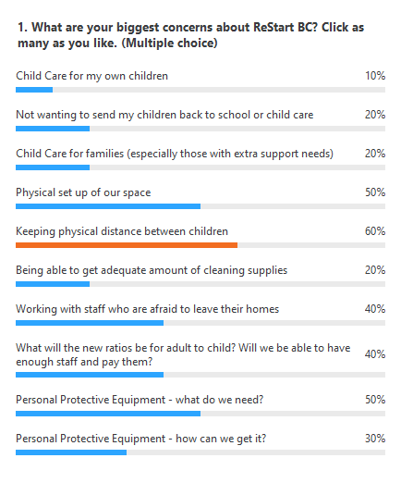
  - Susan; links which have been recommended as good resources about restarting;
    - https://www.worksafebc.com/en/resources/health-safety/checklist/covid-19-safety-plan?lang=en

    - https://www2.gov.bc.ca/assets/gov/health/about-bc-s-health-care-system/office-of-the-provincial-health-officer/covid-19/covid-19-pho-guidance-childcare.pdf
- New Business
Other:
  - Jo-Anne; enjoyed tips and tricks session on May 25. Found out when reading a book and wanting to post about it you need permissions from authors, etc. just be aware. (copyrights)
  - Susan; good point, we found out this applies to music as well. Alison did a one pager that I’ll send out with the minutes. It’s gone well and have more things coming up.
  - Ginna; in terms of sharing pieces coming out around policies. If people want to share creative ways of doing things how would we find this information, without creating things that are in place. Is there a way to tap into things that have already been happening? (working with groups, children, etc.)
    - Susan; we can form a little working group to share this information, learning from other people. Planning templates possibly coming out for social service agencies, I will share information I receive on this.

Next Meeting – Decided every 2 weeks, will schedule a couple of more meetings and re-assess; next meeting will be June 10@1:00 p.m.

