Ridge Meadows CCT Check-In August 19, 2020
Host: Susan Foster
Platform: Zoom
Attendees: 11

Check-In:
- Emily; finished website, not much else happening. Involved with BC Vaping project, working on one for secondary students now.
- Helen; still continuing to meet outside, sticking to same locations for each group (consistent). MR is a good turnout Not sure about September if we’ll be going inside anywhere, reaching out to our places. We usually shut down for 2 weeks but we decided to only shut down for 1. Few new referrals, few new joined.
- Melanie; admin back trying to figure things out, highschool as well. Senior team is fully back, reading through documents. Strong start will be able to run in some capacity, will be going through guidelines today and what it will look like – it will be funded to operate.
- John; staff are back in office 60%, still doing programs outside. Primarily outside visits with children that are supported. Looking at having virtual workshop coming up for child care providers.
- JoAnne/Lyndsey; continuing with busy bags and park visits, huge increase in referrals for child care. Large increase in CPP referrals as well. CCRR is open now by appointment only.
- Cherie; not much update for Big Brother and Big Sisters, waiting to get MOU back from School district to do our mentoring. We have virtual set up if we can’t get into the school. Hired a virtual co-ordinator. Huge influx in volunteers and littles, lots of parents reaching out since pandemic. Lots looking for help and connection for their kids.
- Liza; library re-opened to public August 4th, all libraries open now with reduced hours. Not sure if word has got out yet as it’s been fairly quiet. Still doing curbside pick ups, phone assistance and virtual programs.
- Glenda; 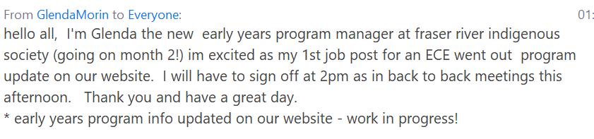
- Jenny; last day of Mural painting at the back. Groups still running through summer, received another grant to extend/expand multicultural group. Continuing in park until it gets too cold, only a very small indoor space to use. Considering outdoor walking groups, etc.
- Susan; just wrapped up summer workshop series today, great attendance and feedback. Survey will be sent out.

Parent and Service Provider Surveys:
- Close on August 28th - please promote and share

Website:
- is live! If you have feedback let us know
- Emily designed 3 potential logos – something more generic, sent out survey link with agenda, please go look and VOTE for your favorite. Do we want to have a logo contest at some point?
Townhall:
- Still working on this, Division of Family Practice is looking for funding for physicians, they will get back to us. Probably looking at October. One in Tri-Cities coming up next week, still have more space.
Infographic:
- Everyone likes it! Susan and Jenny will use it as a guide going forward.
- Emily suggested adding it to the website (great idea!)

Return to School;
- Lots of parents concerned about sending kids back, anxiety, etc. Feeling unsupported.
- Some kids also feeling worried, worried about following the rules but others not.

EDI/MDI Presentation;
- Jenny: SPARC (Maple Ridge) will be running meeting September 17th on Zoom – from 5 to 7 p.m., invite will come out. Would appreciate your presence around this table if possible. The information is being presented to people that have very little understanding, you will be able to help with breakout groups, answer questions, etc.
Next Meeting;
- Return to monthly meetings – will send out calendar invitations and we can always pull together emergency meetings in between, if needed
- September 16th at 1:00 p.m.

