Ridge Meadows Community Children’s Table Meeting Notes

May 13, 2020

1:00 p.m.

Type of Meeting: Via Zoom
Meeting Facilitator: Jenny Earley
Notes: Susan Foster
Attendees: 16
- Territory Acknowledgement
- Share Agenda
- Ask for Additions
- Corrections to Notes from May 13 - none

- Check-in (round)
- Christina/CN Coordinator; working on this week’s what’s happening – send items today; 42 people at last CN meeting – looking at some ways to make the meetings more creative with a large group – next meeting June 9
- Drea/ SD 42: meeting today to determine the gradual return to school plan; 53 kids for karate (online)
- Afton/PM library: still working at home; looking at how to connect with public; focused on online programming
- Ginna/FRIS: looking at protocols for opening; some things in place for staff; still working on how to deal with groups of clients; looking at outside venues (easier), bagged lunches; need to consider access to washrooms and keep groups short; looking at how to use plexi glass for inside meetings
- Helen/Westcoast Family: coming in to office 1 day a week; groups will not be what they were for a long time; meals big part of the program; trying to change up Zoom meeting format by delivering ingredients for a dish and then doing a demo (trying this in PoCo as a test); when connecting with clients for drop-offs – they seem to really want in-person connection; trying to see what would be possible for more in-person connecting
- Jackie/City of PM: city going through risk assessments; looking at BCRPA recommendations; more answers by the end of the week; task force did a share of resources; postings out for Bylaws officers
- Jo-Anne/Community Services CCRR; trying to figure out how many can we have in the building at one time; marking space with tape and posters; staff health check-in list; talking about how to meet with clients – office vs. other places; still doing online workshops; dropping off child care appreciation gifts; Family Place doing online circle time
- Melanie/SD 42: many logistics for June 1st return for those who wish to send kids back – ratios are to be 50%; still working on health and safety protocols; WTK – 5 schools left – have done this outside – lots of creativity from the various schools
- Natalie/Family Ed: focused on training and courses this week
- Nikki/Family ed: workshop on conflict resolution went well; pathfinders next week; did empathy group in school – worked well; 58 kids (35 families) in Schools Out program; 1 spot left in Brave New You; waitlists for other programs
- Wendy/RMACL: step 1 getting people back in the office safely; looking at creative ways to do observations (e.g. “over fences”?)
- Susan/MCFD: looking at space layouts for all our offices, many of which are shared with community agencies; hybrid model of staff at home and at office, depending on needs; online work will continue for the foreseeable future
- Kerry/FSIBC: increased security for Zoom calls due to hacking; she will share their learnings
- Massie/Family Leaf (Family Ed): still doing virtual programs; looking at how to do a gathering in the park
- Jenn/City of MR
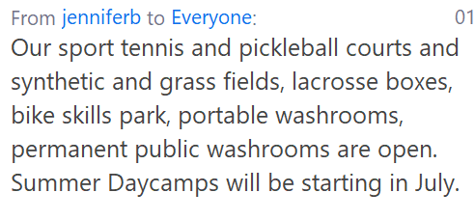

- Business Arising
  - Website – domain and website somehow got disconnected – Jenny working on it; she will let us know when it is up and running again
  - Virtual Platforms Sessions – flyer went out today – please register with Susan @ Susan.Foster@gov.bc.ca; good response already; limiting it to early and middle years folks. Two sessions on May 25 and two on June 1

- New Business
  - RestartBC – poll and discussion – What are your biggest concerns about Re-Start BC:
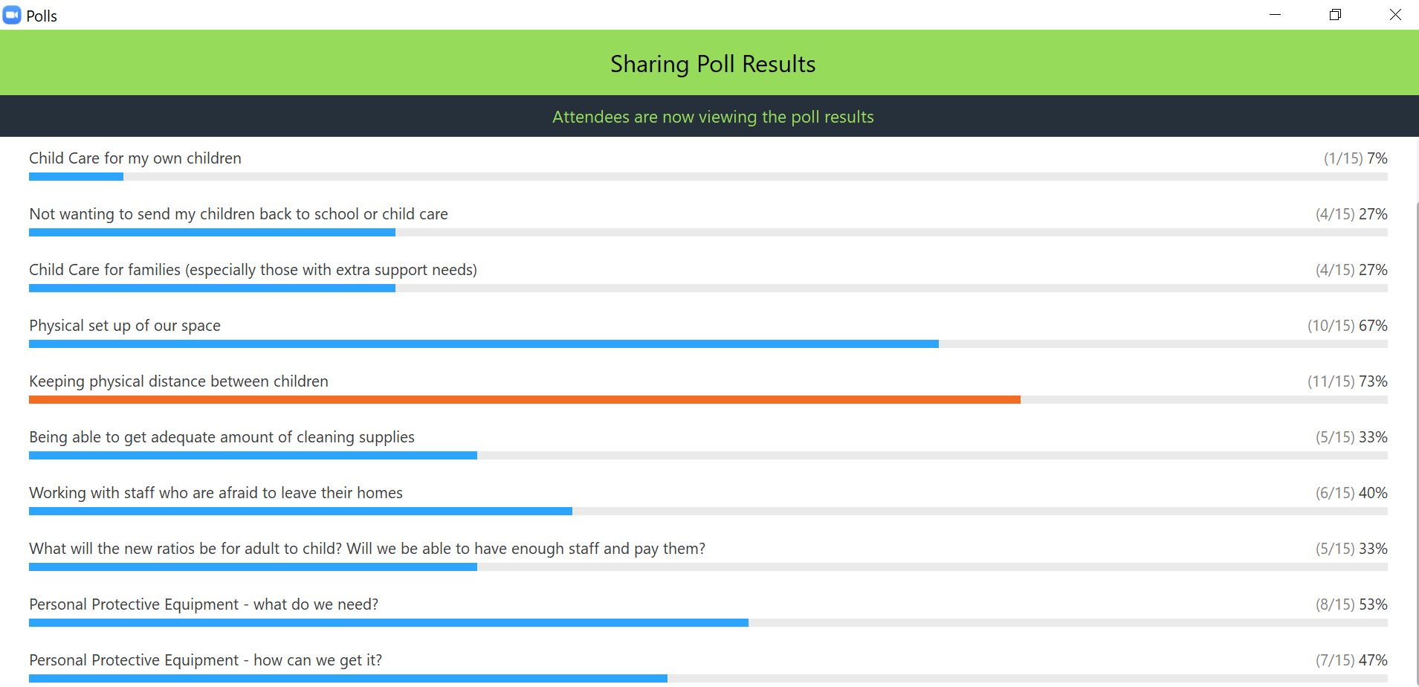

What are people doing about physical distancing for children?
- Try to have defined space for kids to sit at (apart from each other)
- Many groups working on figuring out protocols
- How do we keep play happening?
- Outdoor programming
- Some online programming
- Children are not believed to be super spreaders
- Small groups of children may be a potential strategy
- Cleaning/hand washing protocols
- Activity boxes
- Clean bins/dirty bins for when toys and equipment have been used and then cleaned
- Child care guidelines:

  - Surveys – Parent and Staff surveys are out – will close on May 29th. Please share them. If you have parents doing the translated versions, please have them send those to nfearlyyears@gmail.com

- Next Meeting –May 27 @ 1:00 p.m.

