Ridge Meadows Community Children’s Table

Meeting Notes

June 10th, 2020

1:00 p.m.
Meeting Facilitator: Jenny Earley
Attendees: 16
Territory Acknowledgement
Share Agenda
Ask for Additions
Minutes from last meeting.
Business Arising
- Surveys
results (Susan Foster/MCFD)
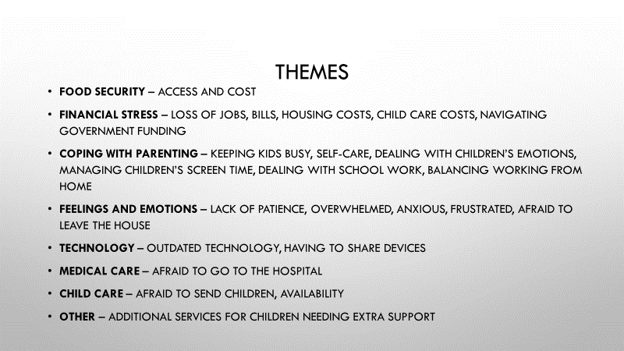
- Susan will send the link to the report out to everyone
- Discussion:
- It helps inform me where we can start focusing. We’ve done up front work, but it gives a bit of backing to what we’ve been doing and will be great to provide what we can, put forward for funding
- Ginna: looking for advice on which devices to purchase as we have some funding available, what platform are the schools using, etc.
- Drea: my understanding that every student and family that needed on was given one, can contact school to get one if needed.
- Jenny: may still be a need though if there are bigger families, adults working from home, etc.
- Ginna; some families under age of 6 not yet connected to school board, could possibly use one for story time, circle time, etc.
- Susan: we could do a quick survey (2 question) to families or staff to say; what type of device they’re using? What platform? If you had the opportunity to borrow a device… Susan will discuss with Ginna
- Jenny: reassuring to know that service providers and parents are on the same page.
- Christina: screen time – we see middle years age range an inability to end game well, frustration management. Associated behavior, it changes how they act, the energy, concepts around team work, fair play, etc.

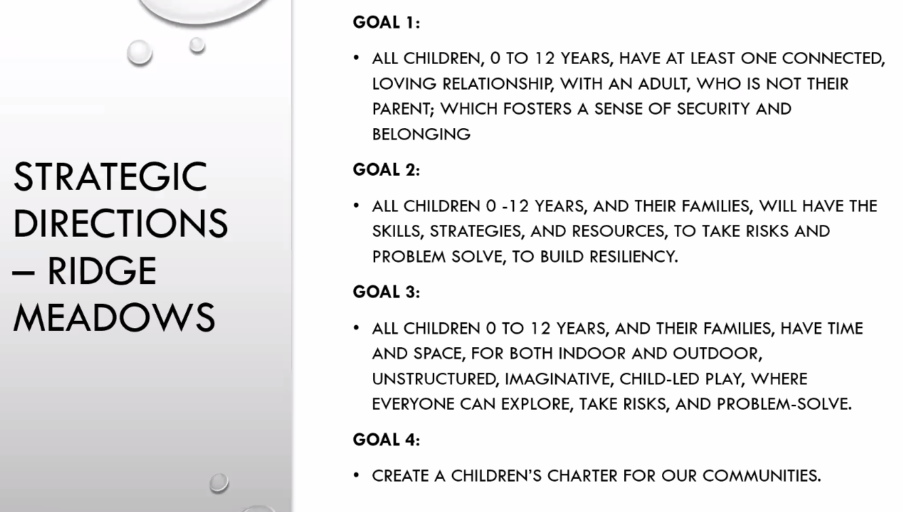
- individually and as a community we’re all working on these things, is there a way we can work on these as a table? Maybe it’s enough for now that we’re already working on these?
- Susan: couple of ideas;
- connected with division of family practice for an info session around covid, going back to school, etc.
- Families Canada: family resource and parent education around early childhood – doing series of short webinars, broken down around social and emotional development. Possibly try and offer some Pro-D for staff? Tips and tricks to encourage parents or do with them to reduce stress around these areas.
- sound like great opportunities; finding it hard to look forward to positive solutions to the deep issues that are arising. It would be beneficial to focus outside, bring others in and listen to what they have to say. For our mental health, our community, our families, etc.
- good idea, maybe we can do something through the newspaper, flyers?
- information overload – want to be aware of that. When in the middle of anxiety and fear info doesn’t always make it through the way we want it to. Maybe some messaging around time for positivity, etc. less about giving tools and ideas but rather a message around thinking forward, not information overloading
- Jenny: no requirement to contact city if moving to parks. Can we somehow ‘schedule’ the park time among us all to share the joy and not double book?
- Melanie: it’s easy to space in the school areas but you don’t want to show up and it all being used. Good idea
- have to choose non-destination parks that aren’t busy due to participant size, if people are hanging around you can’t keep them away
Susan: is everyone ok if I move forward the division of family practice idea? YES

- Website – update and new domain name.
    - Jenny: domain actually expired, and name/domain has separated from each other. Need to wait until it’s available and apply for it again. Discussed changing domain name to accurately reflect that it’s a children’s table.
    - Christina: options for moving forward – including 0-12, did some quick searches and there are a lot of options; what is ok to have in title and what’ so to abbreviate? Ridge Meadows = RM, RMCChildrenstable.ca, RMCommunitychildrenstable.ca, RMC-childrens-table.ca
New Business
Round Table
- Melanie: Our last ELE was about being outside. We are really thinking forward for next year with our strong starts and K’s encouraging more outdoor learning. *see attached newsletter – this gets sent out to new kindergarten parents weekly coming to school in September. Lots of anxiety for these parents.
- Wendy: We are also working on having groups activities outside for the summer.
- Drea: Summer learning – it will be happening for elementary students again this year for 3 weeks in July however, it will look similar to school learning currently. Less students, half days, 2 days a week. We will not be offering the after-recreation partnership program with parks and recreation.
- Jen Baille: The child care needs assessment child care action plan was endorsed by council last night. We will be working on the plan to share all of the info out to the community next.

Next Meeting – June 24th 1.00pm

